**PRACTICAL 2 part1**

**AIM:.**  **Create following layouts using Div Tag**

**DESCRIPTION:**

<A> TAG🡪 it is used to inscribe link inside your web page.

<H3> TAG🡪 heading font size tags

<H4> TAG🡪 heading font size tags

<LINK> TAG🡪this tag is used to make the external css code work from the same html page.

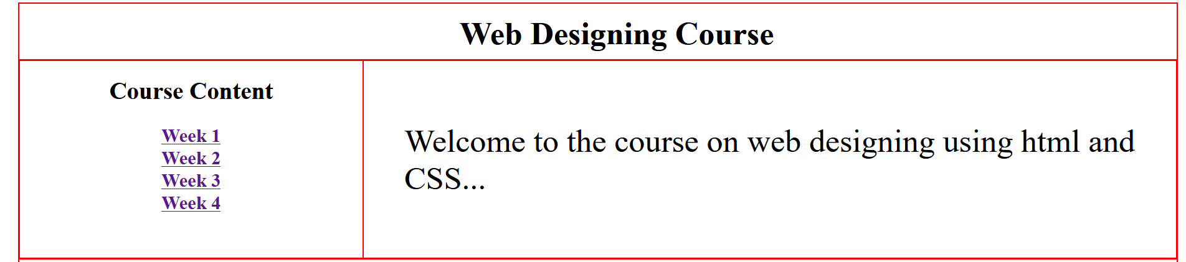

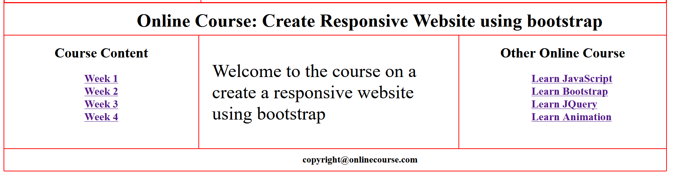

**CONCLUSION:**

Used to create tables using css properties and table properties and also inscribing links inside columns.